Proiect la Elemente Avansate

De Baze de Date

Banci

Bancomat

Danci Anca Denisa

Informatica Economica, an III, grupa III

2021-2022

**Scenariu**

In cadrul acestei baze de date este surprinsa activitatea bancilor in legatura cu bancomatele.

Fiecare banca are un sediu central de care apartin una sau mai multe agentii din diverse locatii. Tot de banca, apartin si bancomatele care se pot afla si in afara agentiilor. Acestea au o limita de bani cash care se pot retrage zilnic, dar aceasta difera in functie de politica bancii respective. Un bancomat poate opera mai multi clienti, dar de asemenea si un client poate folosi mai multe bancomate. In baza de date retinem date despre client cum ar fi nume, CNP, adresa si numar de telefon. Un client poate efectua una sau mai multe tranzactii la bancomat. Fiecare client detine unul sau mai multe conturi, fie in lei sau euro, acestea identificandu-se prin codul IBAN. Pentru a putea realiza operatiuni in cadrul unui bancomat si nu numai, fiecare cont poate avea unul sau mai multe carduri, insa nu pot exista doua carduri cu acelasi nume de detinator asignate unui singur cont.

**Diagrama ERD**

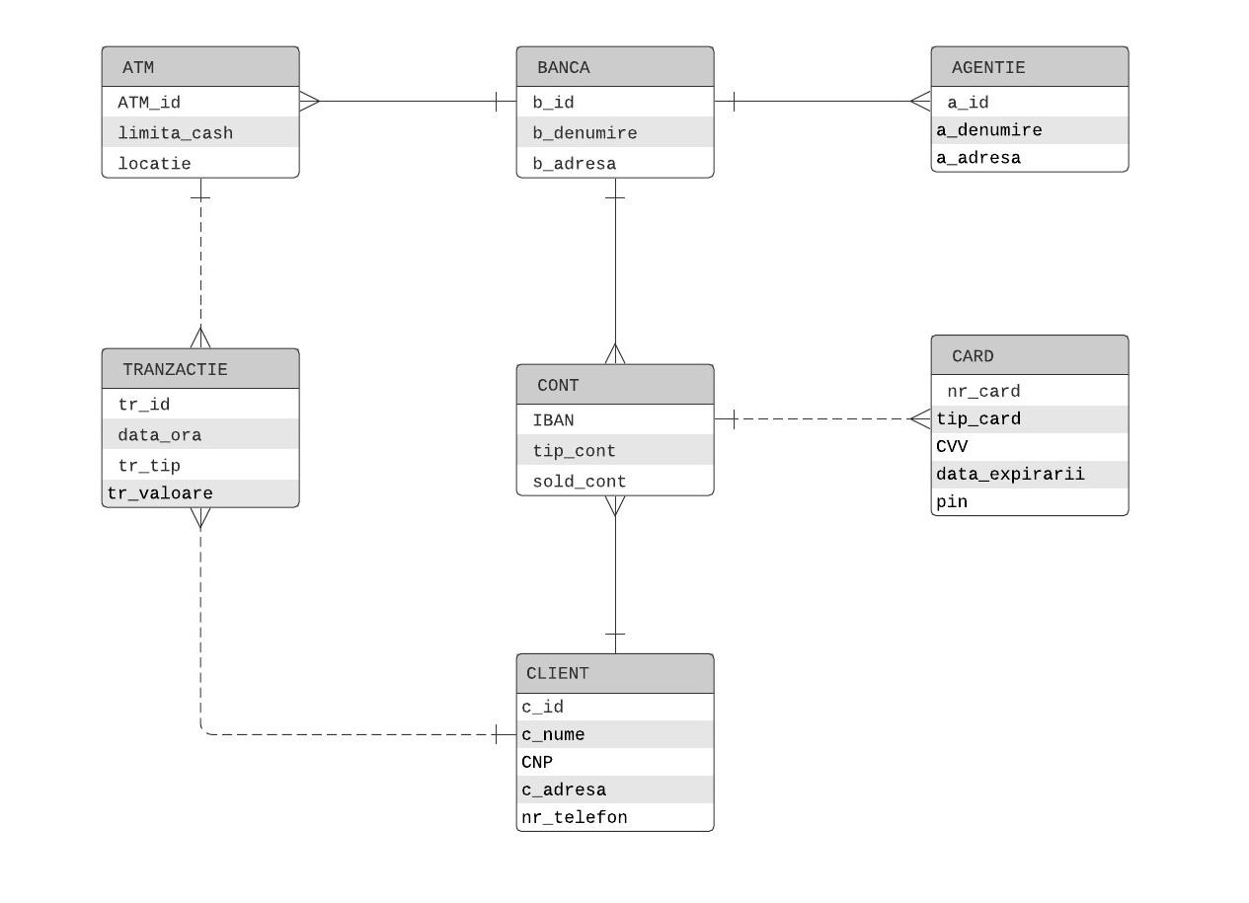

**CREARE TABELE**

* **Creare tabela Banca**

CREATE TABLE Banca (

b_id varchar2(4),

b_denumire varchar2(50) NOT NULL,

b_adresa varchar2(50),

constraint Banca_PK PRIMARY KEY (b_id)

using INDEX ENABLE

);

* **Creare tabela Agentie**

CREATE TABLE Agentie (

a_id number,

a_denumire varchar2(50) NOT NULL,

a_adresa varchar2(50),

a_banca varchar2(4) NOT NULL,

constraint Agentie_PK PRIMARY KEY (a_id)

using INDEX ENABLE

);

ALTER TABLE Agentie

ADD CONSTRAINT Agentie_FK

FOREIGN KEY (a_banca)

REFERENCES Banca (b_id);

CREATE SEQUENCE Agentie_seq

START WITH 1

INCREMENT BY 1

NOCACHE

NOCYCLE;

CREATE OR REPLACE TRIGGER Agentie_trg

BEFORE INSERT ON Agentie

FOR EACH ROW

BEGIN

  SELECT Agentie_seq.NEXTVAL

  INTO   :new.a_id

  FROM   dual;

END;

* **Creare tabela ATM**

CREATE TABLE ATM (

ATM_id number,

limita_cash number,

locatie varchar2(50),

ATM_banca varchar2(4) NOT NULL,

constraint ATM_PK PRIMARY KEY (ATM_id)

using INDEX ENABLE

);

ALTER TABLE ATM

ADD CONSTRAINT ATM_FK

FOREIGN KEY (ATM_banca)

REFERENCES Banca (b_id);

CREATE SEQUENCE ATM_seq

START WITH 1

INCREMENT BY 1

NOCACHE

NOCYCLE;

CREATE OR REPLACE TRIGGER ATM_trg

BEFORE INSERT ON ATM

FOR EACH ROW

BEGIN

  SELECT ATM_seq.NEXTVAL

  INTO   :new.ATM_id

  FROM   dual;

END;

* **Creare tabela Client**

CREATE TABLE Client (

c_id number,

c_nume varchar2(50) NOT NULL,

c_adresa varchar2(50) NOT NULL,

nr_telefon varchar2(12) NOT NULL,

CNP varchar2(20) NOT NULL,

constraint Client_PK PRIMARY KEY (c_id)

using INDEX ENABLE

);

ALTER TABLE Client

ADD CONSTRAINT cnp_unique UNIQUE (cnp);

* **Creare tabela Cont**

CREATE TABLE Cont (

IBAN varchar2(40),

tip_cont varchar2(20) NOT NULL,

sold_cont number,

client_cont number NOT NULL,

banca_cont varchar2(4) NOT NULL,

constraint Cont_PK PRIMARY KEY (IBAN)

using INDEX ENABLE

);

ALTER TABLE Cont

ADD CONSTRAINT Cont_FK1

FOREIGN KEY (client_cont)

REFERENCES Client (c_id);

ALTER TABLE Cont

ADD CONSTRAINT Cont_FK2

FOREIGN KEY (banca_cont)

REFERENCES Banca (b_id);

* **Creare tabela Card**

CREATE TABLE Card (

nr_card varchar2(20),

tip_card varchar2(20),

cvv number(3) NOT NULL,

data_expirarii date NOT NULL,

pin number(4) NOT NULL,

nume_detinator clob NOT NULL,

card_IBAN varchar2(40) NOT NULL,

constraint Card_PK PRIMARY KEY (nr_card)

using INDEX ENABLE

);

ALTER TABLE Card

ADD CONSTRAINT Card_FK

FOREIGN KEY (card_iban)

REFERENCES Cont (IBAN);

* **Creare tabela Tranzactie**

CREATE TABLE Tranzactie(

tr_id number,

data_ora timestamp(0) NOT NULL,

tr_tip varchar2(20),

tr_valoare number,

tr_client number NOT NULL,

tr_atm number NOT NULL,

constraint Tranzactie_PK PRIMARY KEY (tr_id)

using INDEX ENABLE

);

ALTER TABLE Tranzactie

ADD CONSTRAINT Tranzactie_FK

FOREIGN KEY (tr_client)

REFERENCES Client (c_id);

ALTER TABLE Tranzactie

ADD CONSTRAINT Tranzactie_ATM_FK

FOREIGN KEY (tr_ATM)

REFERENCES ATM (ATM_id);

CREATE SEQUENCE Tranzactie_seq

START WITH 1

INCREMENT BY 1

NOCACHE

NOCYCLE;

CREATE OR REPLACE TRIGGER Tranzactie_trg

BEFORE INSERT ON Tranzactie

FOR EACH ROW

BEGIN

  SELECT Tranzactie_seq.NEXTVAL

  INTO   :new.tr_id

  FROM   dual;

END;

**POPULARE TABELE**

* **Populare tabela Banca**

INSERT INTO Banca

VALUES

('BUCU', 'Alpha Bank', 'Calea Dorobanti, nr. 237B, sector 1, Bucuresti');

INSERT INTO Banca

VALUES

('RNCB', 'BCR', 'Calea Victoriei nr. 15, sector 3, București');

INSERT INTO Banca

VALUES

('BTRL', 'Banca Transilvania', 'str. G. Bariţiu nr.8, Cluj-Napoca');

INSERT INTO Banca

VALUES

('BRDE', 'BRD', 'Bd. Ion Mihalache 1-7, sector 1, Bucuresti');

INSERT INTO Banca

VALUES

('RZBR', 'Raiffaisen', 'Calea Floreasca, nr. 246C, Bucuresti');

INSERT INTO Banca

VALUES

('INGB', 'ING', 'str. Aviator Popișteanu, nr. 54A, București');

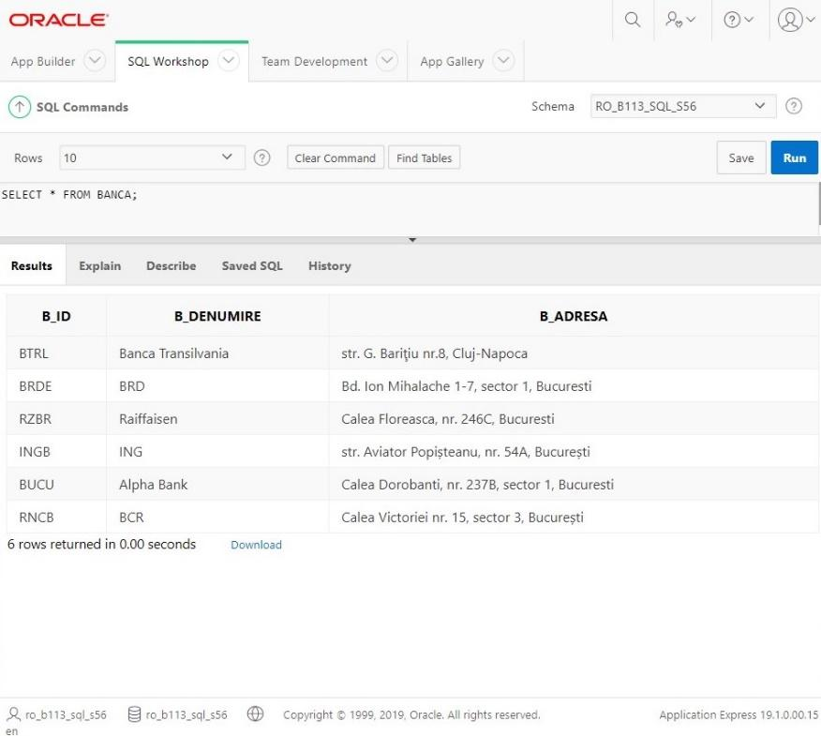

* **Populare tabela Agentie**

INSERT INTO Agentie(a_denumire, a_adresa, a_banca)

VALUES

('Alpha Bank Marasti', 'Strada Fabricii nr. 7, Cluj-Napoca', 'BUCU');

INSERT INTO Agentie(a_denumire, a_adresa, a_banca)

VALUES

('Alpha Bank Zorilor', 'Strada Louis Pasteur, nr. 79','BUCU');

INSERT INTO Agentie(a_denumire, a_adresa, a_banca)

VALUES

('BCR', 'Strada 21 Decembrie, Nr. 16, Cluj-Napoca','RNCB');

INSERT INTO Agentie(a_denumire, a_adresa, a_banca)

VALUES

('BCR', 'Strada Fantanele, Nr. 7, Cluj-Napoca','RNCB');

INSERT INTO Agentie(a_denumire, a_adresa, a_banca)

VALUES

('BT Ferdinand', 'Str. Regele Ferdinand nr. 29, Cluj-Napoca','BTRL');

INSERT INTO Agentie(a_denumire, a_adresa, a_banca)

VALUES

('BT Flora', 'Calea Floresti, Nr. 75, Cluj Napoca','BTRL');

INSERT INTO Agentie(a_denumire, a_adresa, a_banca)

VALUES

('BRD Farmec', 'Strada Henri Barbusse nr. 16','BRDE');

INSERT INTO Agentie(a_denumire, a_adresa, a_banca)

VALUES

('Raiffaisen Brancusi', 'Strada Constantin Brancusi, nr. 149, Cluj Napoca','RZBR');

INSERT INTO Agentie(a_denumire, a_adresa, a_banca)

VALUES

('ING Cipariu', 'Piata Cipariu nr. 11, Cluj Napoca','INGB');

INSERT INTO Agentie(a_denumire, a_adresa, a_banca)

VALUES

('ING Manastur', 'Str. Bucegi nr. 11A, Cluj Napoca','INGB');

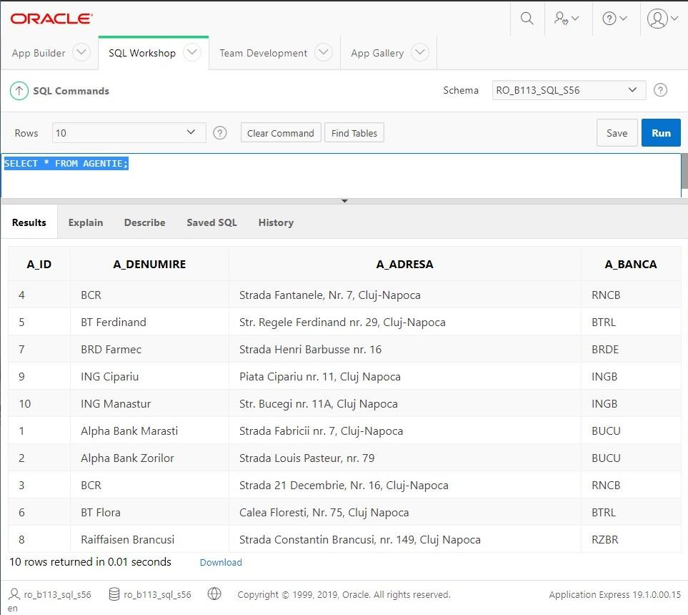

* **Populare tabela ATM**

INSERT INTO ATM(limita_cash, locatie, ATM_banca)

VALUES

(5000, 'Strada Fabricii nr. 7, Cluj-Napoca', 'BUCU');

INSERT INTO ATM(limita_cash, locatie, ATM_banca)

VALUES

(3000, 'Strada 21 Decembrie, Nr. 16, Cluj-Napoca', 'RNCB');

INSERT INTO ATM(limita_cash, locatie, ATM_banca)

VALUES

(5000, 'Str. Regele Ferdinand nr. 29, Cluj-Napoca', 'BTRL');

INSERT INTO ATM(limita_cash, locatie, ATM_banca)

VALUES

(5000, 'Strada Henri Barbusse nr. 16, Cluj-Napoca', 'BRDE');

INSERT INTO ATM(limita_cash, locatie, ATM_banca)

VALUES

(5000, 'Strada Constantin Brancusi, nr. 149, Cluj Napoca', 'RZBR');

INSERT INTO ATM(limita_cash, locatie, ATM_banca)

VALUES

(6000, 'Piata Cipariu nr. 11, Cluj Napoca', 'INGB');

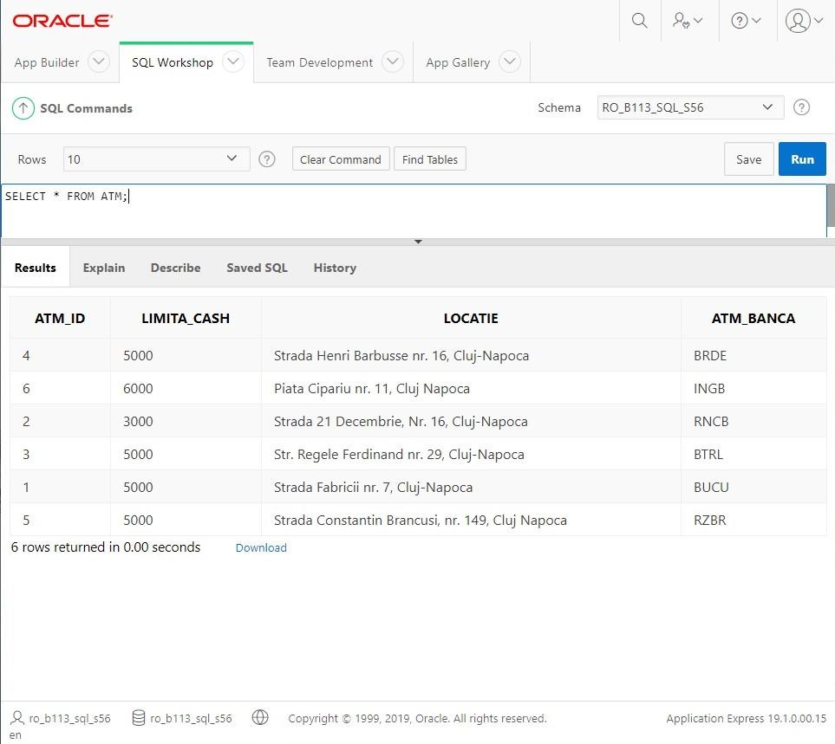

* **Populare tabela Client**

INSERT INTO Client

VALUES

(9876541,'Timis Iulia','Str. Oltului nr 84, Cluj-Napoca', '0756789990','2900908365504');

INSERT INTO Client

VALUES

(1232248,'Stecko Daiana','Str. Crinului nr 7, Cluj-Napoca', '0776843435','2870624015336');

INSERT INTO Client

VALUES

(2436778,'Botezan Vlad','Str. Muresului nr 1, Cluj-Napoca', '0740388093','1941129188640');

INSERT INTO Client

VALUES

(9907211,'Marchis Alexandru','Str. Armoniei nr 5, Cluj-Napoca', '0756786453','5000601519940');

INSERT INTO Client

VALUES

(3445342,'Ghilea Georgiana','Str. Fagului nr 17, Cluj-Napoca', '0722114567','6010708229787');

INSERT INTO Client

VALUES

(6548733,'Tise Tudor','Str. Lunii nr 112, Cluj-Napoca', '0744289556','1971116405094');

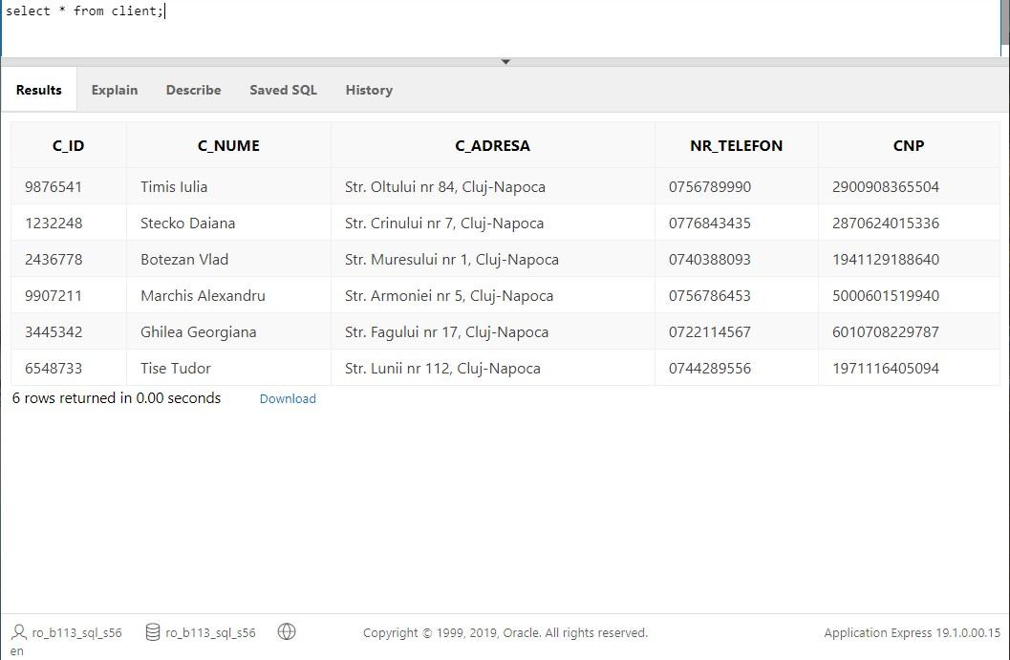

* **Populare tabela Cont**

INSERT INTO CONT

VALUES

('RO49BUCU1223425687934536','LEI','7000','9876541','BUCU');

INSERT INTO CONT

VALUES

('RO30BTRL8767239861276454','EURO','1000','2436778','BTRL');

INSERT INTO CONT

VALUES

('RO30BTRL8767239861276452','LEI','1200','2436778','BTRL');

INSERT INTO CONT

VALUES

('RO17RNCB7623465987012006','LEI','30000','9907211','RNCB');

INSERT INTO CONT

VALUES

('RO78RZBR0004523477859671','EURO','300','1232248','RZBR');

INSERT INTO CONT

VALUES

('RO55INGB0043999452346587','LEI','970','6548733','INGB');

INSERT INTO CONT

VALUES

('RO32BRDE0073699412311589','EURO','2050','3445342','BRDE');

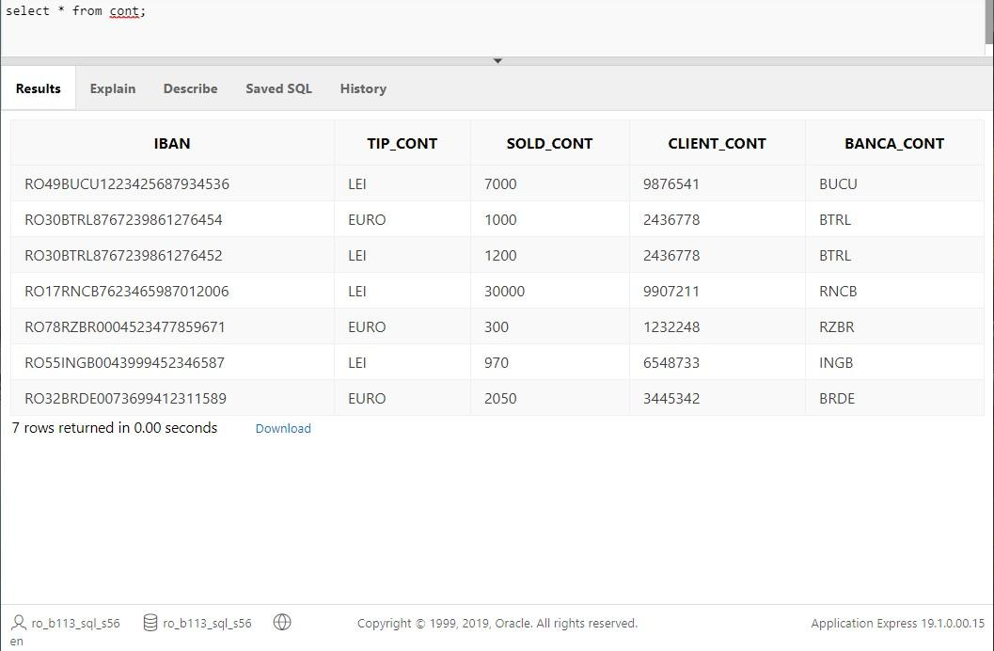

* **Populare tabela Card**

INSERT INTO CARD

VALUES

('4140789065456756','visa','552', to_date('03/22', 'MM/YY'), 2341, to_clob('Timis Iulia'),'RO49BUCU1223425687934536');

INSERT INTO CARD

VALUES

('5678563423654532','visa','222', to_date('03/22', 'MM/YY'), 8642, to_clob('Timis Maria'),'RO49BUCU1223425687934536');

INSERT INTO CARD

VALUES

('3457678498456998','visa','592', to_date('01/23', 'MM/YY'), 9167, to_clob('Botezan Vlad'),'RO30BTRL8767239861276452');

INSERT INTO CARD

VALUES

('1276980956476578','omnipass','983', to_date('04/24', 'MM/YY'), 5761, to_clob('Ghilea Georgiana'),'RO32BRDE0073699412311589');

INSERT INTO CARD

VALUES

('7658324258655875','visa','134', to_date('01/22', 'MM/YY'), 4124, to_clob('Tise Laura'),'RO55INGB0043999452346587');

INSERT INTO CARD

VALUES

('4778554677612345','visa','441', to_date('01/22', 'MM/YY'), 1111, to_clob('Tise Tudor'),'RO55INGB0043999452346587');

INSERT INTO CARD

VALUES

('6754769800658754','mastercard','738', to_date('02/23', 'MM/YY'), 2931, to_clob('Stecko Daiana'),'RO78RZBR0004523477859671');

INSERT INTO CARD

VALUES

('4123453467568765','mastercard','962', to_date('07/25', 'MM/YY'), 7741, to_clob('Marchis Alexandru'),'RO17RNCB7623465987012006');

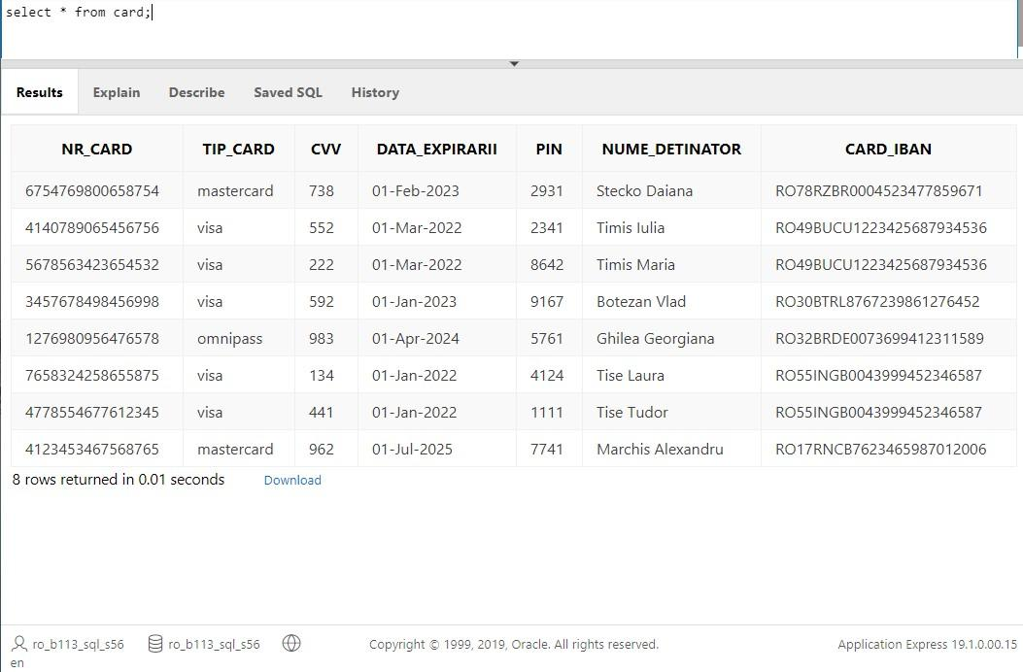

* **Populare tabela Tranzactie**

INSERT INTO Tranzactie(data_ora, tr_tip, tr_valoare, tr_client, tr_ATM)

VALUES

(TIMESTAMP'2021-05-01 17:01:30','retragere numerar', 500,3445342, 1);

INSERT INTO Tranzactie(data_ora, tr_tip, tr_valoare, tr_client, tr_ATM)

VALUES

(TIMESTAMP'2021-05-01 19:00:50','sold cont', NULL, 3445342, 4);

INSERT INTO Tranzactie(data_ora, tr_tip, tr_valoare, tr_client, tr_ATM)

VALUES

(TIMESTAMP'2021-05-02 11:12:39','depunere numerar', 250, 1232248, 5);

INSERT INTO Tranzactie(data_ora, tr_tip, tr_valoare, tr_client, tr_ATM)

VALUES

(TIMESTAMP'2021-05-03 13:54:19','schimbare pin', NULL, 9876541, 1);

INSERT INTO Tranzactie(data_ora, tr_tip, tr_valoare, tr_client, tr_ATM)

VALUES

(TIMESTAMP'2021-05-06 08:01:48','schimb valutar', 450, 6548733, 6);

INSERT INTO Tranzactie(data_ora, tr_tip, tr_valoare, tr_client, tr_ATM)

VALUES

(TIMESTAMP'2021-05-06 20:08:12','retragere numerar', 800, 2436778, 3);

INSERT INTO Tranzactie(data_ora, tr_tip, tr_valoare, tr_client, tr_ATM)

VALUES

(TIMESTAMP'2021-04-10 23:43:18','depunere numerar', 950, 9907211, 2);

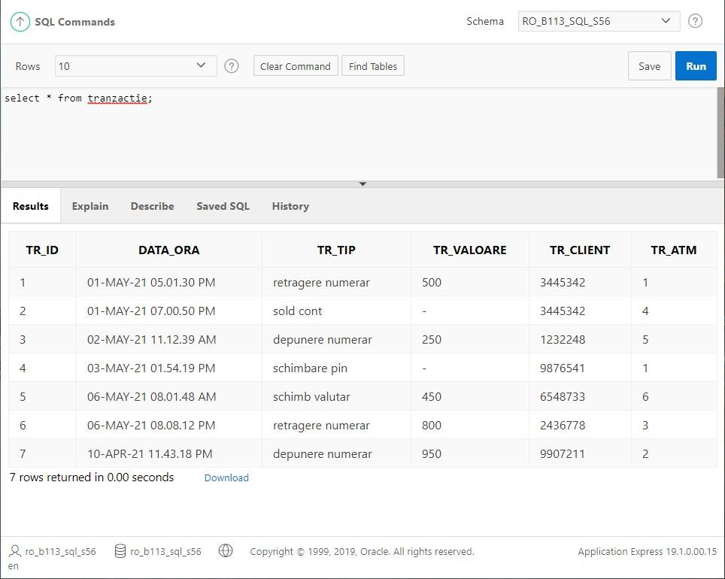

**PACKAGE**

CREATE OR REPLACE package pack_atm as

function nr_tranzactii(p_tr IN client.c_id%TYPE) return int;

function total_sold(p_id cont.client_cont%type) return number;

procedure sterge_tranzactie(p_tr in tranzactie.tr_id%type);

procedure sterge_tranzactii0;

procedure afisare_nrtr;

procedure afisare_atm;

procedure actualizare_limita;

end;

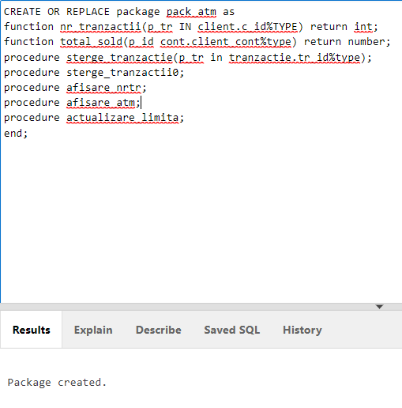

* **functie care returneaza nr de tranzactii efectuate de un client**

function nr_tranzactii(p_tr in client.c_id%type) return int is

v_tr INT :=0;

cursor nr_tr is select tr_id from tranzactie where tranzactie.tr_client=p_tr;

r_tr nr_tr%ROWTYPE;

begin

open nr_tr;

loop

fetch nr_tr into r_tr;

exit when nr_tr%NOTFOUND;

end loop;

v_tr := nr_tr%ROWCOUNT;

return v_tr;

close nr_tr;

end nr_tranzactii;

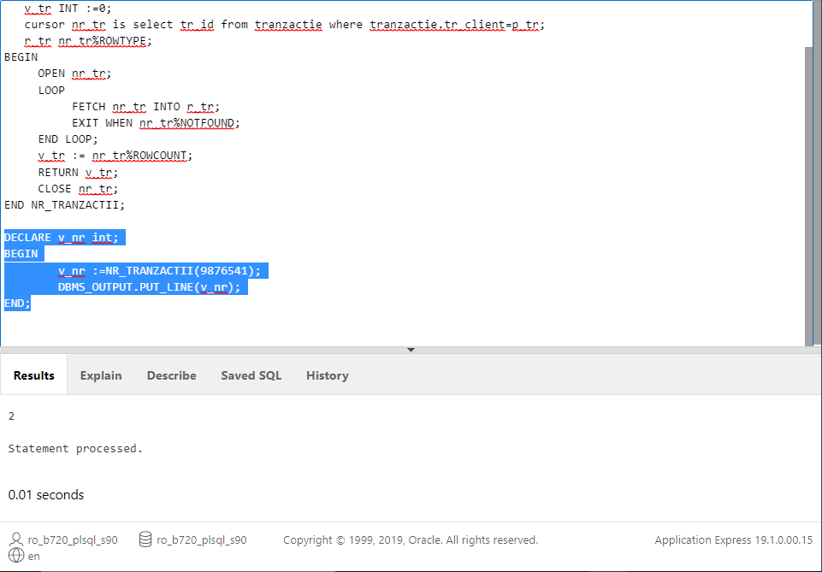

* **functie care returneaza soldul conturilor detinute de acelasi client**

function total_sold(p_id cont.client_cont%type) return number is

v_total number :=0;

cursor c_conturi is select sold_cont from cont where client_cont=p_id;

begin

for v_sold in c_conturi loop

v_total:=v_total + v_sold.sold_cont;

end loop;

return v_total;

end total_sold;

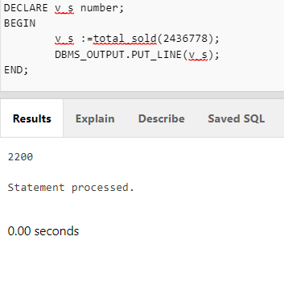

* **procedura care sterge o tranzactie**

procedure sterge_tranzactie(p_tr in tranzactie.tr_id%type) is

v_tr tranzactie.tr_id%type;

begin

select tr_id

into v_tr

from tranzactie

where tr_id = p_tr;

delete from tranzactie where tr_id=p_tr;

dbms_output.put_line('Stergere finalizata cu succes pentru tranzactia cu codul '|| v_tr);

exception

when no_data_found then

dbms_output.put_line('Tranzactia '|| p_tr ||' nu exista!');

end sterge_tranzactie;

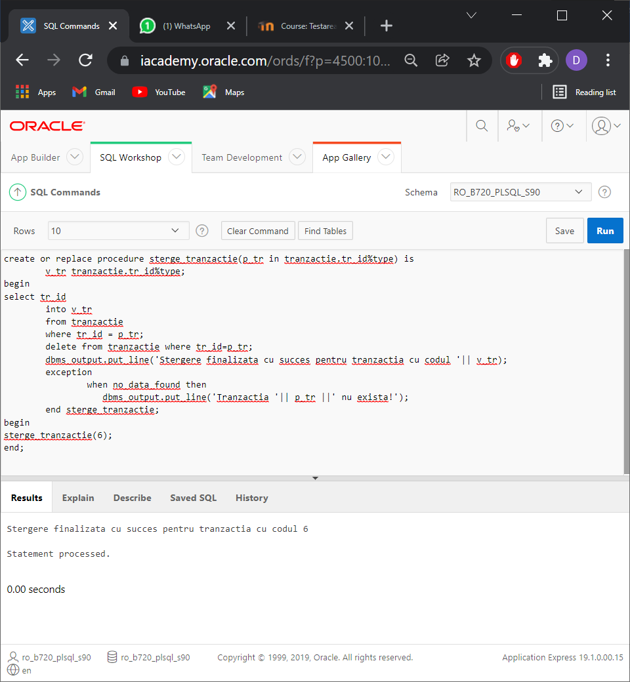

* **procedura care sterge tranzactiile care au valoare nula (ex: interogare sold) folosindu-ne de procedura sterge_tranzactie**

procedure sterge_tranzactii0 is

v_tr tranzactie.tr_id%type;

cursor c_tr0 is select tr_id from tranzactie where tr_valoare is null;

begin

open c_tr0;

loop

fetch c_tr0 into v_tr;

exit when c_tr0%notfound;

sterge_tranzactie(v_tr);

end loop;

close c_tr0;

end sterge_tranzactii0;

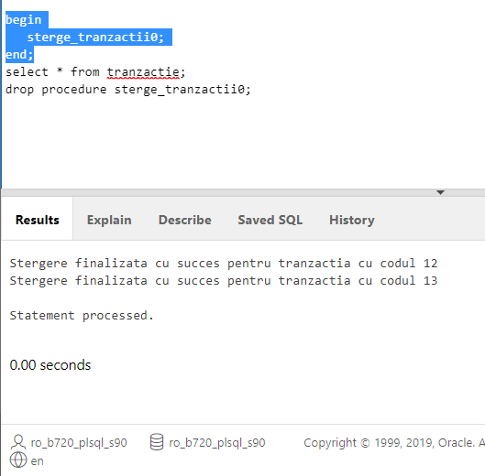

* **procedura care afiseaza numele si nr de tranzactii efectuate de clientii din Cluj-Napoca folosindu-ne de functia nr_tranzactii**

procedure afisare_nrtr is

cursor c_clienti is select c_id, c_nume, nr_telefon

from client WHERE REGEXP_LIKE (c_adresa, 'Cluj Napoca') OR REGEXP_LIKE (c_adresa, 'Cluj-Napoca');

v_nume client.c_nume%type;

v_nrtel client.nr_telefon%type;

v_nrtr int:=0;

v_id client.c_id%type;

begin

open c_clienti;

loop

fetch c_clienti into v_id, v_nume, v_nrtel;

if c_clienti%FOUND then

v_nrtr := nr_tranzactii(v_id);

DBMS_OUTPUT.PUT_LINE(v_nume || ' ' || v_nrtel || ' ' || v_nrtr);

end if;

exit when c_clienti%NOTFOUND;

end loop;

close c_clienti;

end afisare_nrtr;

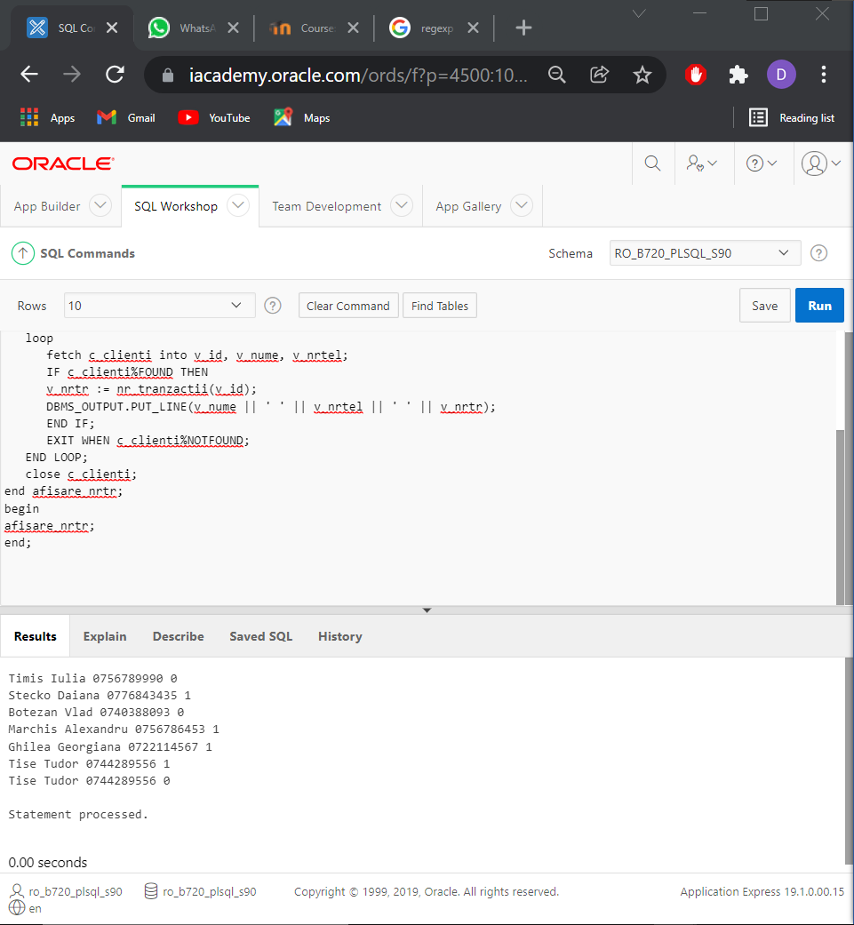

* **procedura care afiseaza locatia si limita de cash a atm-urilor in functie de banca**

procedure afisare_atm is

cursor c_banci is select distinct atm_banca from atm;

cursor c_atm(p_banci atm.atm_banca%TYPE) is

select * from atm where atm_banca=p_banci;

v_contor int := 0;

v_contor_global int := 0;

begin

for v_banci in c_banci loop

DBMS_OUTPUT.PUT_LINE('======' || v_banci.atm_banca || '======');

for v_atm in c_atm(v_banci.atm_banca) loop

v_contor_global := v_contor_global + 1;

v_contor := v_contor + 1;

DBMS_OUTPUT.PUT_LINE(v_contor_global || '. ' || v_atm.locatie || ' ' || v_atm.limita_cash || ' ' || '(' || v_contor || ')');

end loop;

v_contor := 0;

end loop;

end afisare_atm;

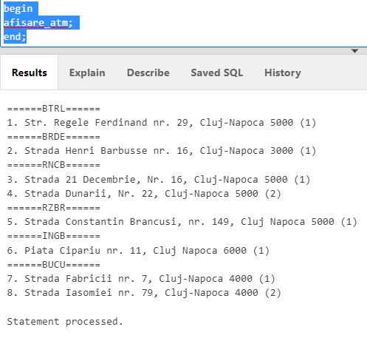

* **procedura care actualizeazeaza limita de cash sub 4000 a bancomatelor, adaugand inca 1000**

procedure actualizare_limita is

cursor limita_cursor (max_limit number) is

select atm_id, limita_cash

from atm where limita_cash < max_limit for update of limita_cash;

v_id atm.atm_id%type;

v_limita atm.limita_cash%type;

begin

open limita_cursor(4000);

loop

fetch limita_cursor into v_id, v_limita;

exit when limita_cursor%NOTFOUND;

update atm set limita_cash=v_limita+1000 where v_id=atm_id;

end loop;

close limita_cursor;

end;

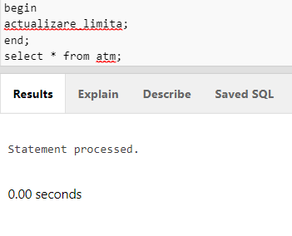

**Declare**

**v_nr int;**

**v_s number;**

**Begin**

**v_nr :=nr_tranzactii(9876541);**

**DBMS_OUTPUT.PUT_LINE(v_nr);**

**v_s :=total_sold(2436778);**

**DBMS_OUTPUT.PUT_LINE(v_s);**

**sterge_tranzactii0;**

**afisare_nrtr;**

**afisare_atm;**

**actualizare_limita;**

**End;**

**SECVENTE**

CREATE SEQUENCE Agentie_seq

START WITH 1

INCREMENT BY 1

NOCACHE

NOCYCLE;

CREATE SEQUENCE ATM_seq

START WITH 1

INCREMENT BY 1

NOCACHE

NOCYCLE;

CREATE SEQUENCE Tranzactie_seq

START WITH 1

INCREMENT BY 1

NOCACHE

NOCYCLE;

**DECLANSATORI**

* **declansatori utilizati pentru inserarea automata a valorilor de id pentru tabelele Agentie, ATM si Tranzactie**

CREATE OR REPLACE TRIGGER Agentie_trg

BEFORE INSERT ON Agentie

FOR EACH ROW

BEGIN

  SELECT Agentie_seq.NEXTVAL

  INTO   :new.a_id

  FROM   dual;

END;

CREATE OR REPLACE TRIGGER ATM_trg

BEFORE INSERT ON ATM

FOR EACH ROW

BEGIN

  SELECT ATM_seq.NEXTVAL

  INTO   :new.ATM_id

  FROM   dual;

END;

CREATE OR REPLACE TRIGGER Tranzactie_trg

BEFORE INSERT ON Tranzactie

FOR EACH ROW

BEGIN

  SELECT Tranzactie_seq.NEXTVAL

  INTO   :new.tr_id

  FROM   dual;

END;

* **declansator utilizat pentru verificare valoarii introduse sau actualizate a campului limita_cash pentru a fi in intervalul [2000, 10000]**

CREATE OR REPLACE TRIGGER limita_cash

BEFORE INSERT OR UPDATE OF limita_cash ON ATM

FOR EACH ROW

BEGIN

IF :NEW.limita_cash < 2000 THEN

RAISE_APPLICATION_ERROR (-20202,'Limita minima admisa este 2000 lei!');

ELSIF :NEW.limita_cash > 10000 THEN

RAISE_APPLICATION_ERROR (-20203,'Limita maxima admisa este 10000 lei!');

END IF;

END limita_cash;